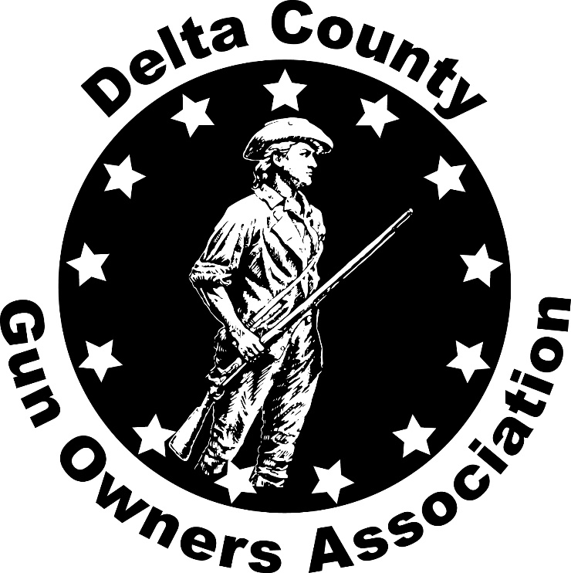

August, 2019 Newsletter

Mission statement;
“To promote the safe and legal ownership and use of firearms as expressed in our inalienable rights under the Second Amendment to the Constitution of the United States of America so that those who are legally permitted to purchase and sell firearms may collect and use firearms for competitive events or for other sporting purposes.
Also preserving and defending the right to keep and bear arms as guaranteed by the Bill of Rights and Article I, section 6 of Michigan’s Constitution.
A well-regulated Militia being necessary to the security of a Free State, the right of the people to keep and bear Arms shall not be infringed.
President: Bill Hawley (906) 280-4388
Vice President: Kathie Scott
Secretary: Larry Johnson
Treasurer: Jim Groos
Director: Bob Petersen (906) 280-4733
deltacountygunowners@gmail.com
www.protectmygunrights.com

Meetings held at Mead Rod and Gun Club on County Road 420

This month’s meeting has been rescheduled for Tuesday, September 17, 2019. Meeting time is 6:30 p.m.
The 2nd Amendment March is on September 10th and all board members will be in Lansing.

Come out at 5:00 and shoot on the range. Bring your firearms, ammo and targets.

We now have 296 members.

Past Events
- We had a booth at the UP State Fair again this year. As in past years, the booth was a big success for us. We sold a lot of 10 gun raffle tickets and again raffled a gun during the week of the fair. The fair gun, a Savage Axis was won by Mark Hawley. Congratulations, Mark.
- We conducted a Basic Pistol Class in July with 4 students and 4 instructors.
- The joint DCGOA/MOC picnic was held on August 3rd at Ludington Park. 3 planes flew up from Lower Michigan for the event. What a great day it was.
- Bill attended the Menominee Parks Commission meeting on August 15th to address the park rules that bans firearms in all County Parks. After informing the commission of the unlawful nature of the rule and potential consequences for the county if the rule were enforced, the commission passed a motion for the County Administrator to rewrite the rules regarding firearms to make it comply with state law. He will submit the change to the County Board for approval. We will monitor the process to be sure it is completed.

Mead Sportsman’s Association (MSA) Issue
MSA and the complainants came to an agreement for the pistol range. The Zoning and Planning Board recommended to the Township Boar that a building permit be issued so the range can be built. At the Board meeting a week later, the Township Attorney stated the agreement was good, BUT, that was not binding. He stated that since the range is not 40 acres, the property has to be re-zoned and a “non-conforming use” permit granted. It was referred back to the Zoning commission. This is likely to take 4-6 weeks.

Upcoming Events
- The 2nd Amendment March will be held in Lansing on Tuesday, September 10th. This is why we rescheduled our monthly meeting to Tuesday, September 17th.
- We have a Basic Rifle Class scheduled for September 21st. Anyone who is interested in attending needs to call the DCGOA phone at 906-241-5632. The class is open to the public so if you know of anyone who might like the class, have them call.
- There are 2 gun shows coming up. The first one is August 30th – September 2nd at the Steam and Gas Engine show. Mike Glass could use more help manning the table. Call Kathie Scott at 420-428-2414.
- The 2nd show is at the United Sportsman’s Club in Iron Mountain on September 20 – 21.
- Autumn Conroy is forming the Banquet Committee. Interested? Let her know. All help is appreciated.

Next meeting is Tuesday, October 8, 2019
Informative links/info
Michigan Open Carry
https://www.miopencarry.org
open carry information
http://www.michigan.gov/documents/msp/MSP_Legal_Update_No._86_2_336854_7.pdf
michigan cpl laws
http://www.michigan.gov/msp/0,4643,7-123-1586_27094-10953--,00.html
public act 377 of 2012
http://www.michigan.gov/msp/0,1607,7-123-1591_3503_4654---,00.html
michigan gun owners
http://www.migunowners.org/
National Association for Gun Rights
https://www.nationalgunrights.org/
Great Lakes Gun Rights
https://greatlakesgunrights.org/
nra
http://home.nra.org/
uscca
https://www.usconcealedcarry.com/
Gun owners prayer:
Dear Lord if I die first, please don't let my wife sell my guns for what I told her I paid for them

